Version <1.0>

Revision History

|  |  |  |  |
| --- | --- | --- | --- |
| **Date** | **Version** | **Description** | **Author** |
| <dd/mmm/yy> | <1.0> | <details> | Nguyen Kiem Hoa |
|  |  |  |  |
|  |  |  |  |
|  |  |  |  |

Table of Contents

1. User Login 4

1.1 Brief Description 4

1.2 Actor 4

2. Flow of Events 4

2.1 Basic Flow 4

3. Special Requirements 4

4. Preconditions 4

5. Postconditions 4

6. Extension Points 4

# User Login

## Brief Description

This use case defines the steps of logging in the software as a user. User can easily login by enter correct username and password.

## Actor

User

# Flow of Events

## Basic Flow

User run the software and login form appears, user fills in that form with username and password. After that, user clicks the login button. If correct username and password, user will enter homepage of software, else they will receive a notification about invalid username or password.

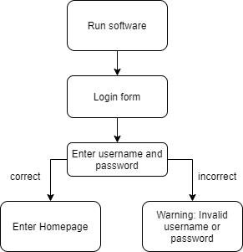

# Special Requirements

Run the software.

# Preconditions

Enter username and password field.

# Postconditions

If correct username and password, user enter homepage

Else warning: Invalid username or password.

# Extension Points

No extension point.